Adding dependencies and designing the page object:
First we will create a new project.
First we will import all the playwright dependencies.
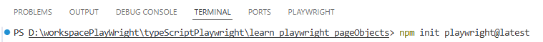
We will add allure report as well.
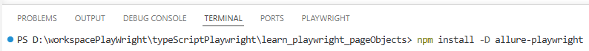
In the config file we will add allure playwright.
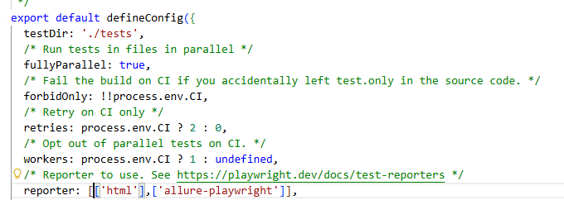
We will also make the following changes in the config file.
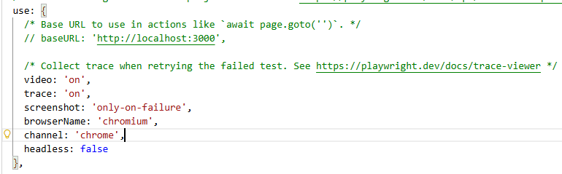
We can comment out webkit since we are on windows.
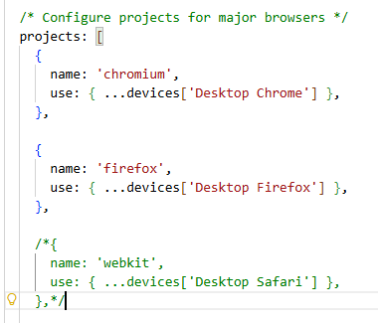
We will also add a timeout of 15000.
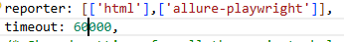
We will add 2 folders for pages and utils.
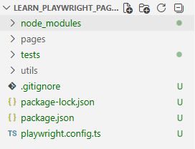
We will be automating https://www.copart.com/
We will be adding the following in the base url
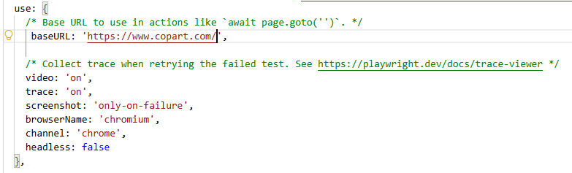
Here we will follow the page object model. This means for every page we will create one class file.
Instead of implementing the business logic in the test cases we will write the same in page object. This will also reduce script maintenance.
If there are multiple functionalities in a single page all of them will come under one class.
For this we will create a new file under pages called HomePage.ts
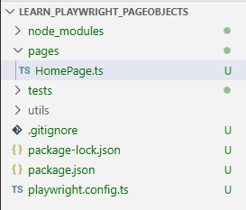

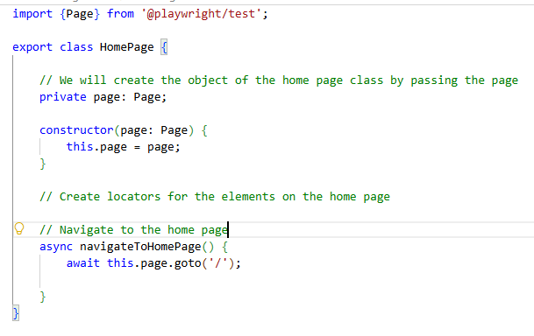
Next we will create a test file.
test.describe => It is a like a test suite which contains a group of related test.
test =>We will write individual test cases.
test.before =>Before every test case we need to navigate to the home page. Before Each hook is executed before every test case gets executed. Here we are creating an object of the home page and then navigating to the home page.
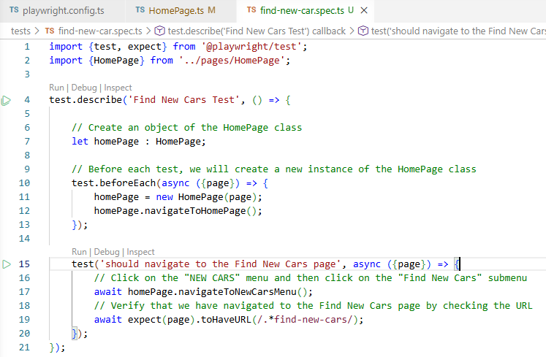
Adding keyword driver approach:
Here we are going to create separate files for each page in the application. We are going to keep the page elements on the top and below we will write the business logic in the form of different functions.
Moreover we will also design a base page which will contain reusable function. It will contain some common methods.
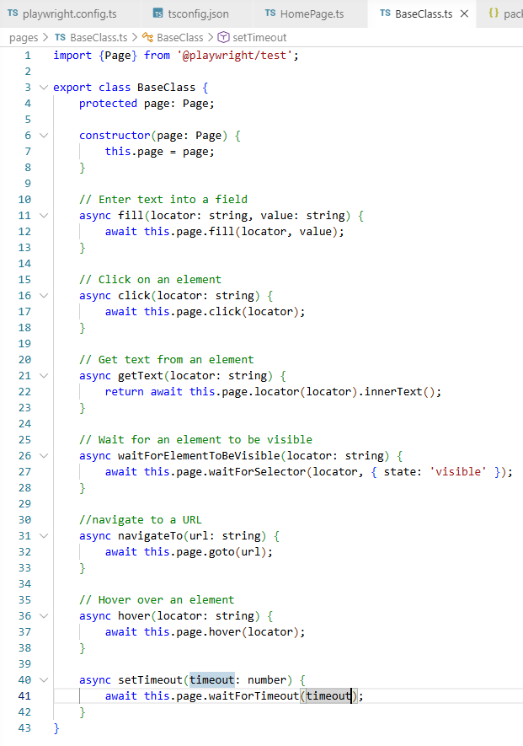
The page classes follow the page factory approach with page elements on the top and business functionalities below.
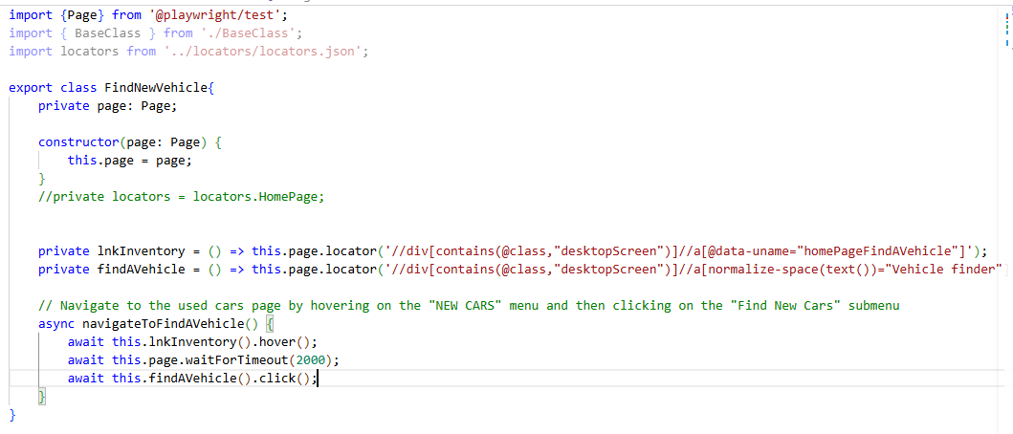
The page classes will extend the base class and use the reusable methods defined in the base class. We will pass the page elements as a string.
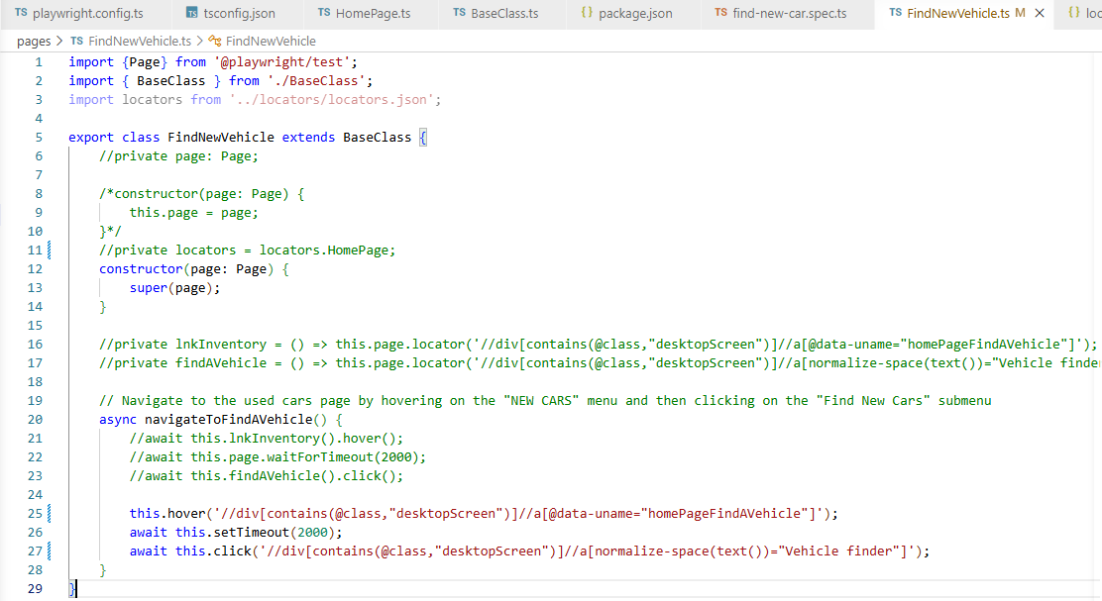

Implementing locators JSON file:
We will segregate the page elements in the locators json file and will use them in the page class.
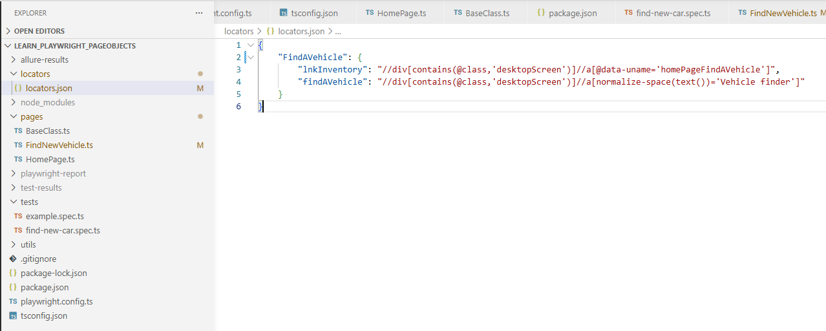
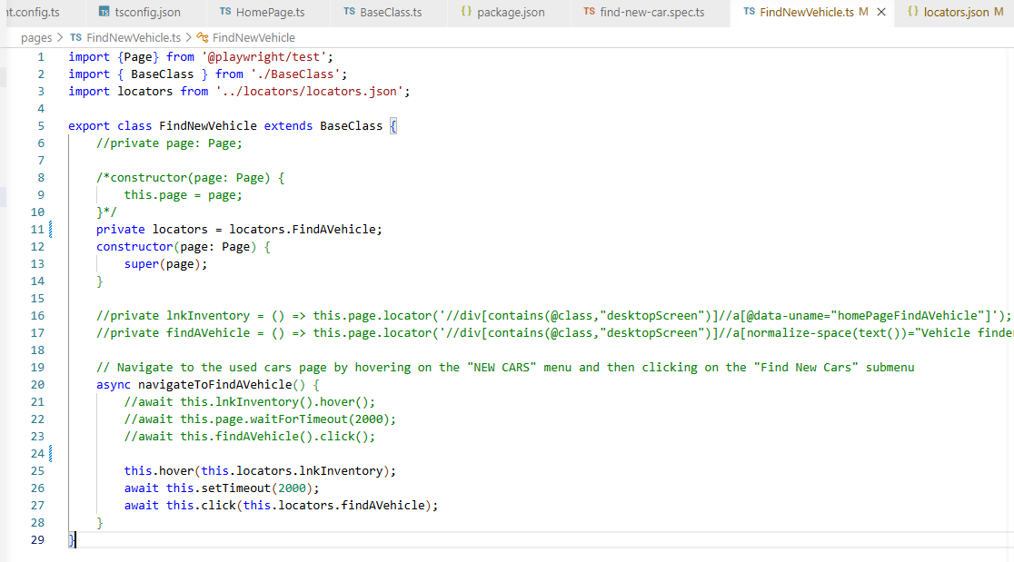

Implementing Registration Page:
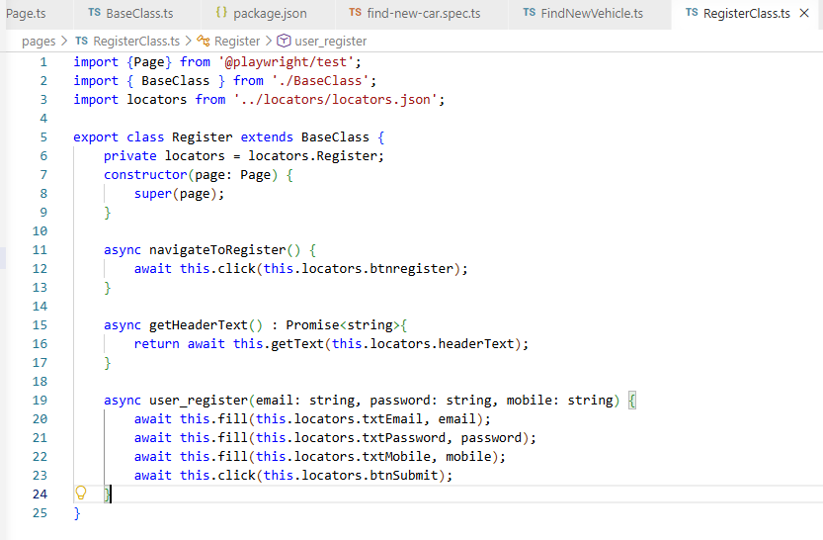
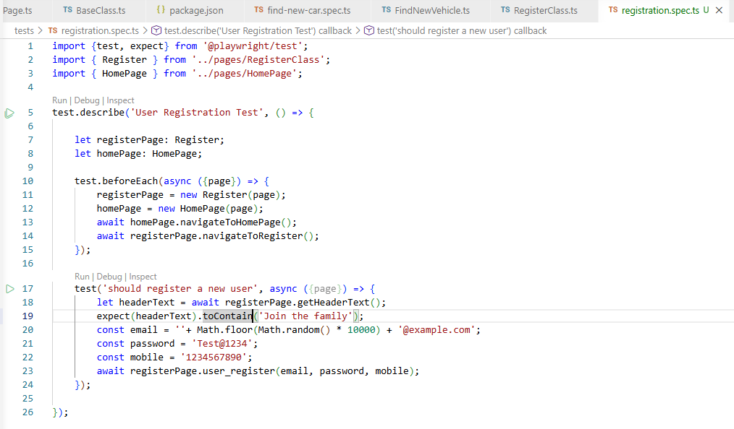
Implementing page fixtures:
We will first create a new folder and name it fixtures. Within the folder we will create a new file called page_fixtures.ts.
Here we will import all the files we have that we will need in our test cases.
We will declare the page we have created so far and create a constructor.
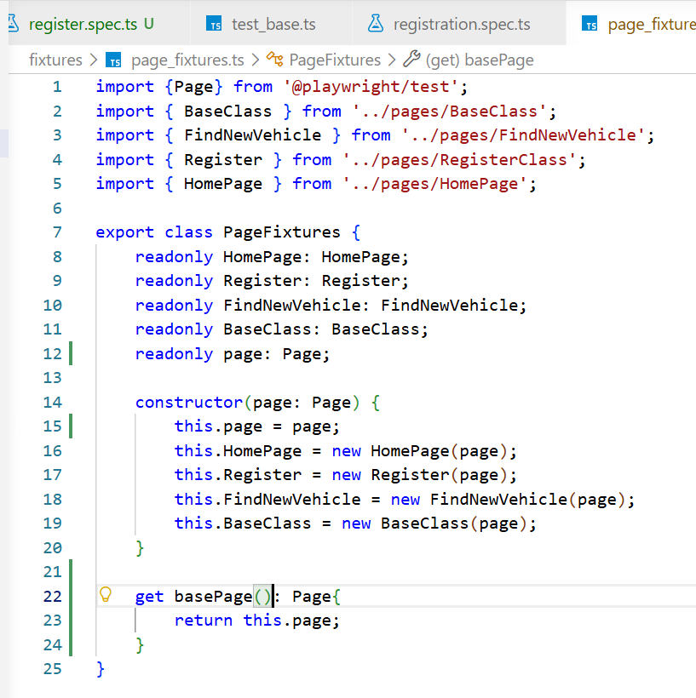
Then under utils folder we will create a file called test_base.ts.
We have defined all the page fixtures in pages object.
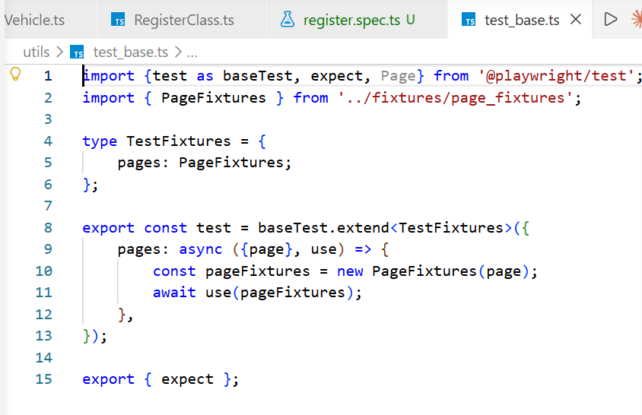
Now we will use the test fixtures in our test.
We will comment out individual imports and will only import test_base which again points to the fixtures file,
In the test rather than calling page we will call the pages object defined in test_base.
We will now call the individual methods using pages object: “await pages.Register.navigateToRegister()”
When we want to access the page object we can access it using pages.page.
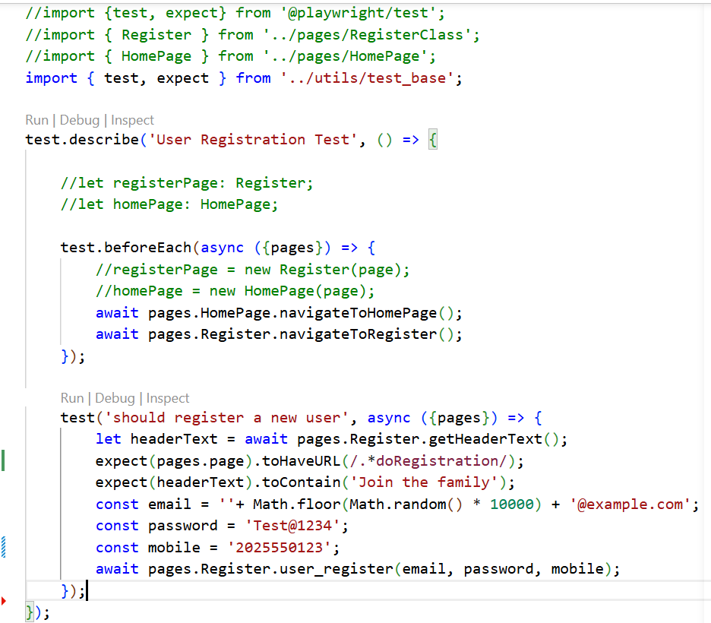
Using page fixtures we should be able to use all the page directly without implementing it individually in each pages.
Implementing test parameterization:
In this example we will read the test data from the CSV file.
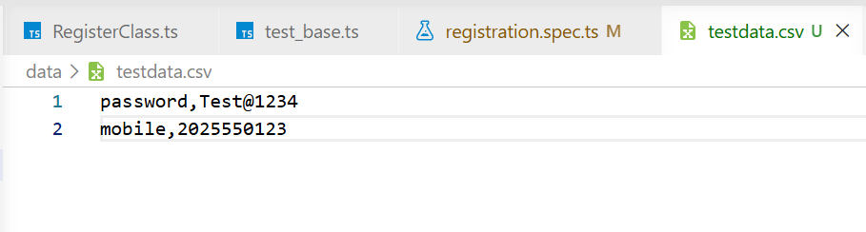
We also need to write the code to read data from csv.
First we will install csv-parse using the command “npm install csv-parse”
